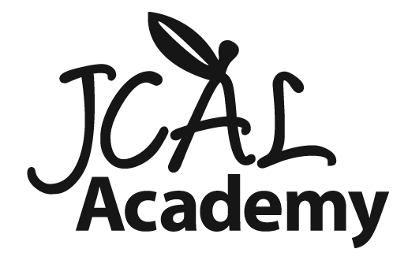 Toddler Summer Camp 2012
Come explore and discover at JCAL Academy Preschool Camp! Program available for children ages 2-5 years. Weekly camps scheduled from June 11 through August 10th. There will be no camp the week of July 2nd. Program runs from 9:30 am -12:30 pm, Monday through Friday. Snack will be included. Please bring a packed dairy/ vegetarian lunch each day. Experienced teachers trained to provide safe, educational, fun experiences for your child!
Cost: $120/week for LJCC non-members
$100/ week for LJCC members
Please contact the director, Stephanie Thomas for more information at 717-560-7572 or jcalacademy@lancasterjcc.org

Toddler Camp (2-3 yrs) Toddler camp is a relaxed morning of play. In addition, the toddlers will get to do some structured activities, such as games and art, while also having time to explore outside. Sprinkler play will be part of each week. Children do not need to be potty trained to attend camp.
June 11- In My Backyard : Explore and learn about the nature around us in our backyards!
June 18- Bugs, Bugs, Bugs: Discover those little creatures outside. We will be examining various types of bugs and doing lots of buggy crafts!

June 25- Wacky Water: Lots of water play in this week as we investigate the properties of water.
NO CAMP THE WEEK OF JULY 2nd
July 9- Up in the Sky: The kids will get to discover the things we see in the sky such as clouds, kites, planes, etc!
July 16- Beach: We will be doing an in-depth exploration of the beach and ocean. Lots of sand and water play will be happening this week!
July 23- Budding Artists: Prepare to get creative as we do many different types of art and artistic styles!

July 30- Picnic Time: Cooking, outside play and fun are the ingredients for this picnic-themed week!
August 6- Silly Science: Investigate the messy and sticky science behind slime, bubbles and so much more!
Preschool Summer Camp 2012
Come explore and discover at JCAL Academy Preschool Camp! Program available for children ages 2-5 years. Weekly camps scheduled from June 11 through August 10th. There will be no camp the week of July 2nd. Program runs from 9:30 am -12:30 pm, Monday through Friday. Snack will be included. Please bring a packed dairy/ vegetarian lunch each day. Experienced teachers trained to provide safe, educational, fun experiences for your child!
Cost: $120/week for LJCC non-members
$100/ week for LJCC members
Please contact the director, Stephanie Thomas for more information at 717-560-7572 or jcalacademy@lancasterjcc.org
Preschool Camp- (3-5 yrs) Preschool camp is a great combination of structured activities similar to enrichment class with free play. Children will have time outside daily and sprinkler play at the teacher’s disscretion.
June 11- Budding Broadway: Calling all actresses and actors for a week exploring the stage. Learn about acting, singing and dancing with a short performance at the end of the week!
June 18- Let’s Pretend: Delve into character development as we get to make masks, costumes, puppets and then use them for improv!
June 25- All Star Sports: Be ready for an athletic packed week of playing outside and learning different sports and excerises.
NO CAMP THE WEEK OF JULY 2nd
July 9- Diggin’ Dinosaurs: Go on a trip to the Jurassic Period as we explore dinosaurs and fossils.
July 16- Rockin’ Rhythms: Kids will learn about percussion, rhythm and have a rockin’ good time!
July 23- Beach Bound: Sand, water and a lot of fun this week as we investigate the beach right here at JCAL!
July 30- Blast off!: Campers will learn about space as they pretend to be astronauts, discover the moon and the planets.
August 6- Little Melody Makers: Kids will get a chance to make instruments and make music during this melodic week of music!

