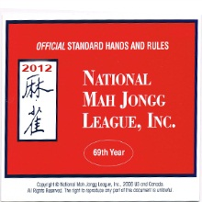

2012 MAH JONGG CARDS
ON SALE NOW

Regular Cards are $7

Big Print Cards are $8

Cards need to be ordered before February 1, 2012. Please send your order and checks made out to “Michele Matlin” at 1171 Country Club Drive, Lancaster, PA 17601. Any questions please contact Michele at (717) 393-2981.

